

All LBMS and NBMS band members will meet at the Belton Middle School drop off loop.

All MS Band members will be escorted by the band directors/chaperones to the visitor’s side bleachers for entry. ONLY Band members, Band staff and adults with valid chaperone wristbands will be allowed to enter with the band.

Middle School Band students will be escorted by the band directors to the Belton MS Drop-off loop for pick up at the start of the 3rd quarter (after the Stampede halftime show). ALL STUDENTS must be picked up at this time.

If MS band students would like to re-enter the game, they will not be allowed to take their instruments back into the game. They will need to take their instruments to a personal vehicle after the halftime performance and re-enter on the HOME to sit in the MS student section. Students will need their student ID card for entry into the stadium. A MS band director will be present at the entrance to approve free return entry for MS band students. If the MS band student does not return within an appropriate time, the band students will not be allowed to re-enter.

Parents: If you would like to re-enter to watch the remainder of the game, you will still need to meet your band student at the Belton MS Drop-off loop and assist them in securing their instrument in a vehicle. In order to re-enter the game, all parents must ask for a RETURN ENTRY PASS upon exiting the stadium.

Band directors will assign parent-chaperones to assist the band with various duties. These parents are given wristbands that allow them access to the band area. This wristband is NOT A TICKET to enter the stadium. All parents are required to purchase a ticket to enter the stadium. All Band members, while under the supervision of BISD Band Directors, will remain on the VISITORS side from the time of drop-off through parent pick up at the start of the 3rd quarter.

Please let us know if you have any questions about this event! Thank you for your support.

Jordan Dolotina Dane Wurman
Director of Bands Director of Bands
Lake Belton Middle School North Belton Middle School
Jordan.dolotina@bisd.net dane.wurman@bisd.net

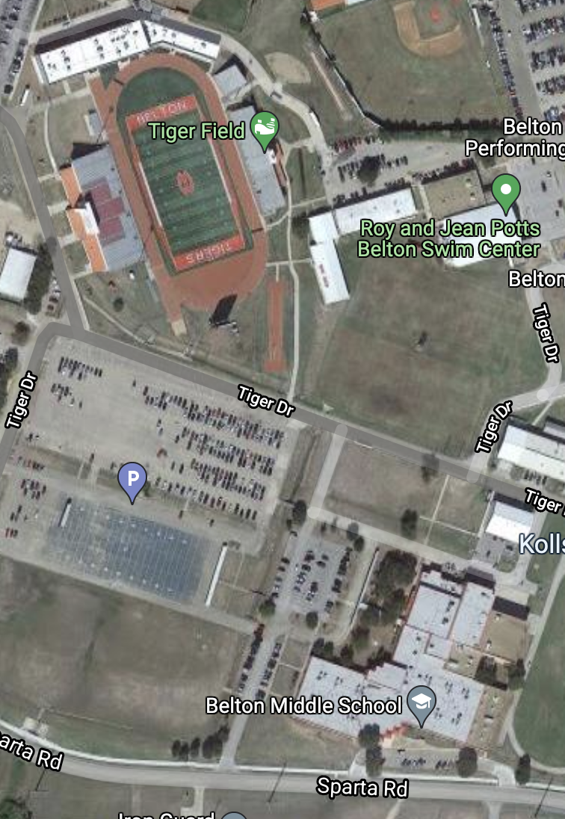
Student Pick up /
Drop off
Pass Gate
Student Section
Band Seating

5:45pm Middle school students dropped off at car rider loop of Belton MS
6:00pm Middle school students move to the stadium visitor’s side.
6:20pm combined MS/HS band rehearses stand tunes in the stands: Land of 1000,
Walkin’ & Talkin’, Happy, Bad Guy
7:00pm pre-game starts (no more warming-up)
7:30pm Game starts
8:45pm approx. start of halftime. The Stampede performs contest show / MS students watch from visitor’s bleachers
Middle school students will be escorted back to the Belton MS car rider loop.

